Sterile Hold Validation
Helper (test version)

User guide
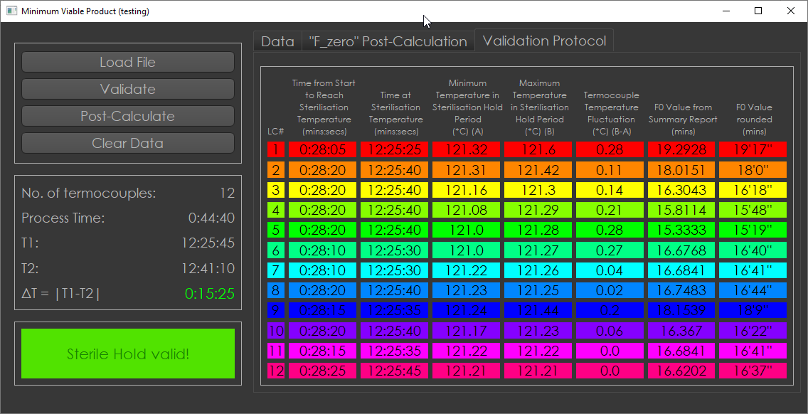
Spis treści
Interface 3

Interface
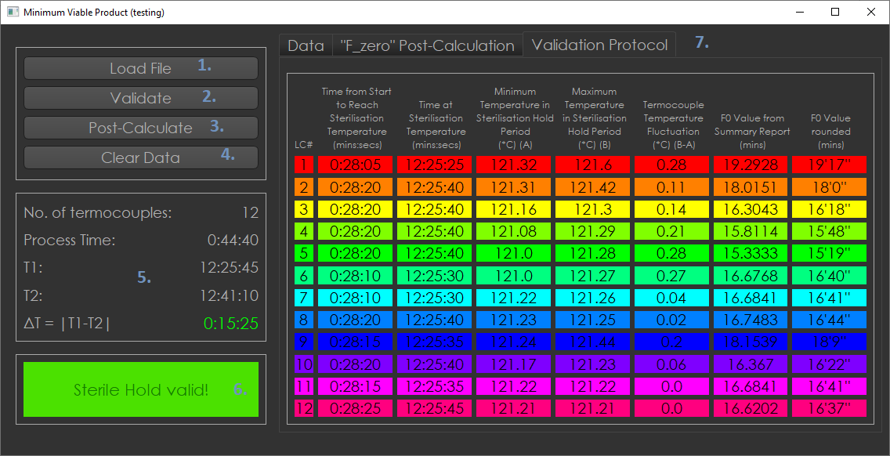
Fig.1. Program User Interface

1. “Load file” button – opens window to let user choose file. At this moment program accepts *.xlsx Excel files. The loaded data are presented at “Data” tab (see Fig.2). Table is interactive, so user can navigate through data. After loading data, a number of termocouples (TC’s) is displayed and overall process time (timestamp from last low from file subtract timestamp from first row) is displayed.
2. “Validate” button – program analyse data loaded from file and finds the time at which last TC reaches 121.0ºC, which starts Sterile Hold Regime (SHR) and displays it as T1, finds the time at which first TC reaches 121.0ºC on SHR, which leads to end of Regime and displays it as T2. ΔT=|T1-T2| is calculated and displayed on the screen. If ΔT is in range between 15 minutes and 15 minutes 30 seconds, the ΔT is coloured as green. If ΔT is above or below that range, it will be coloured as red. The data in the table are “cut” and only data from SHR are displayed (see Fig.3). If during SHR any of TC does not drop below 121.0ºC or rise above 123.0ºC, then the message “Sterile Hold valid!” indicator will have green background. If this rule is not met, then “Sterile Hold invalid!” indicator will have green background.

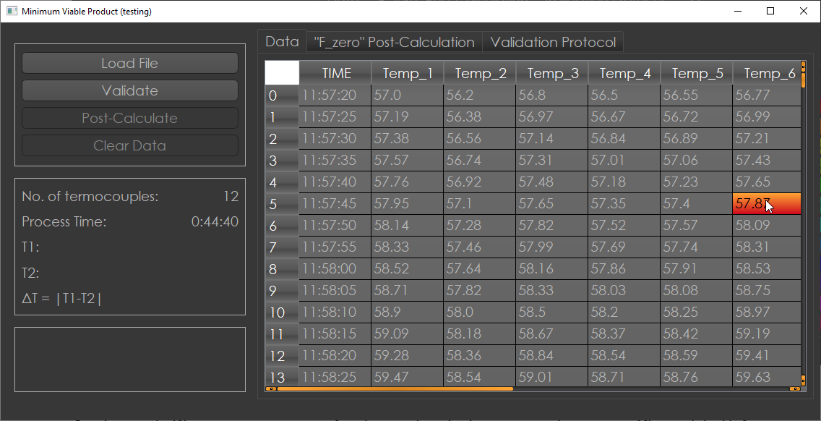
Fig.2. “Data” tab and data representation from file

3. “Post-calculate” button – this button triggers number the plotting sequences and number of calculations. In the “’F_zero’ Post-Calculation” tab the plot of SHR is displayed. The average Value of F0 is calculated for whole SHR (Fig.4). The plot can be interacted with. Zoom-in and zoom-out is done by mouse scroll up and down. To move around the plot user uses drag&drop in the plot window. Legend with TC’s can be moved. When plot is moved, there is possibility to reset the view to the first position by clicking “A” which will appear at the bottom-left corner of the plot. At the plot there are two dotted lines corresponding to lower and upper limit of SHR (121.0⁰C; 123.0⁰C).
Below the plot F_average is calculated as average over all TC F₀. F₀ is calculated as:
(Eq. 1),
where Δt is time between subsequent measurements (assumed 5 seconds) and the z coefficient is set to z=6.0.
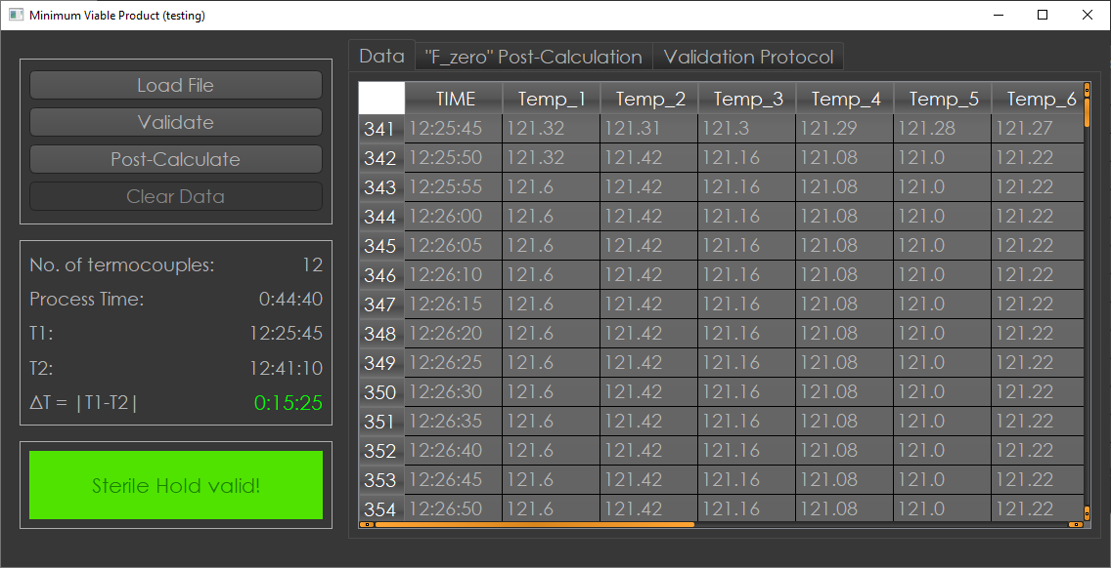
Fig.3. Effect of “Validate” button

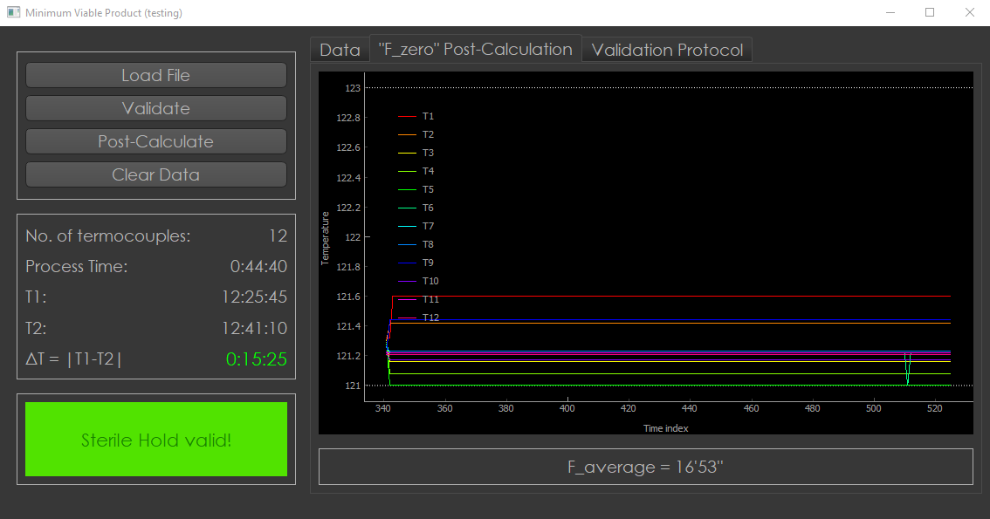
Fig.4. “F_zero” Post-Calculation tab

“Validation Protocol” tab stores a lot of information for individual TC’s (see Fig. 5), such as:
- time from start to reach sterilisation temperature for ever,
- time at sterilisation temperature,
- minimum temperature in sterilisation hold period,
- maximum temperature in sterilisation hold period,
- TC temperature fluctuation,
- F₀ value calculated as in Eq. 1,
- F₀ value rounded and converted to 12’34’’ format (minutes and seconds).

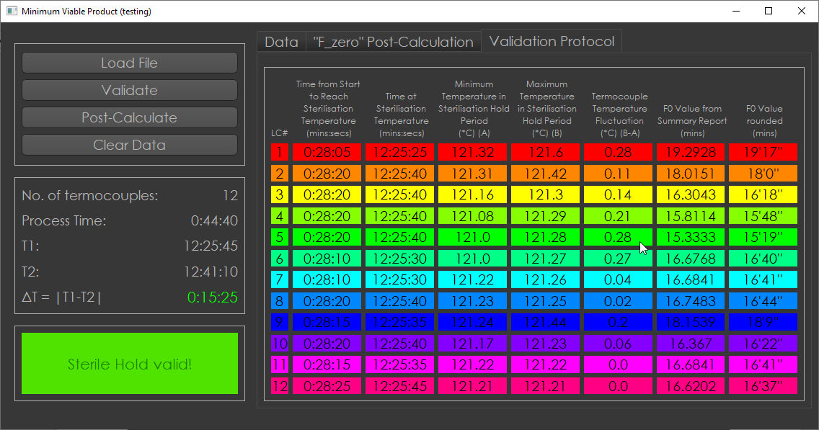
Fig.5. “Validation Protocol” tab

Colouring of data displayed in the “Validation Protocol” tab is the same as in the plot.

4. “Clear Data” button – clears all data from program.

Speed of program
In the following table the performance of this program are presented:
Operation | Time elapsed for completion [s]
Reading data from file and displaying on the “Data” tab | 2.6
Validation of data | 0.01
Post-Calculation of data | 0.64
Clear the data | 0.05

